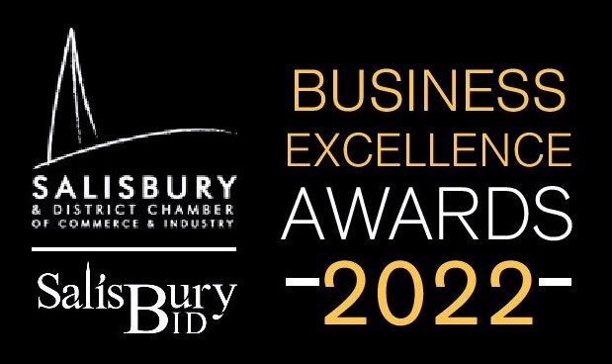
Application form
Business of the Year Award

The Business of the Year award is open to any member who can demonstrate an established market position, excellent growth, expansion plans and resilience as well as effective leadership, innovation, an ethical approach to business and strong results. .
Please complete the following information questions
Business name:
Year established:
Business address:
Business owner:
Business status ie: Limited Company/Partnership/Sole Trader
Number of employed staff:
Number of self-employed staff:
Name of applicant & email:
Relationship to business:
Business turnover:

Please complete the following award questions.
Q1. Type of business - what does it do?
Q2. What is the established market position of this business?
Q3. What is the business's unique selling point / innovation?
Q4. What is the biggest risk to the business and how is it mitigated?
Q5. What is the business Mission Statement?
Q6. What is the 5 year business plan?
Q7. What is the financial position of this business over the past three years?
Q8. How does the business keep its overheads to a minimum?
Q9. During Covid -19 lockdowns, how did the business maintain cashflow?
Q10. How is the business sustainable?
Q11. What is the business’s travel plan?
Q12. Is business support or a company mentor used?
Q13. How does the business attract its customers?
Q14. What is the recruitment, skill and training requirements for this business?
Q15. During Covid -19 lockdowns, how did the business manage employees?
Q16. How does the business deal with complaints?
Q17. What does the business do with positive feedback?
Q18. How does the business reward its employees?
Q19. How does the business support other businesses in the community?
Q20. How does the business support local charities?

Please return this questionnaire, along with any additional supporting information to info@salisburychamber.co.uk before midnight on Friday 11th March.
Please mark the subject line with the category of the award you are applying to win and the business name.
Judges will be in touch week commencing 14th March 2022 if you are required for an interview to gather more information.
Five businesses will be shortlisted for each award. There will be two places reserved for each shortlisted business representative and limited additional tickets available for general sale to members. Tickets are subsidised at £35.00 plus VAT per person.
To order tickets regardless of the award completion, please email as above with the subject line Tickets for BEA 2022.
We look forward to celebrating your business on Friday 8th April.

