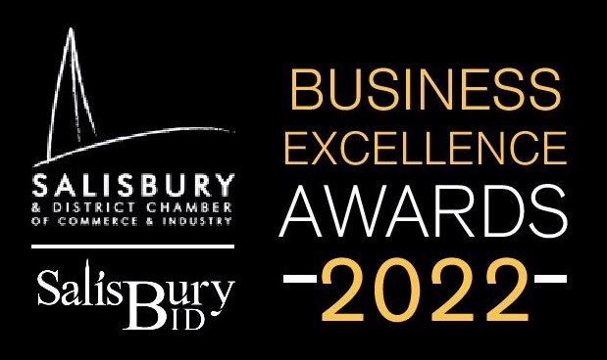
Application form
EMPLOYER OF THE YEAR
The Employer of the Year award is open to any member that employs staff and recognises organisations that go above and beyond for their employees, supporting their development, promoting high standards and providing a happy and healthy work environment.

Please complete the following information questions
Business name:
Year established:
Business address:
Business owner:
Business status ie: Limited Company/Partnership/Sole Trader
Number of employed staff:
Number of self-employed staff:
Name of applicant & email:
Relationship to business:
Business turnover:

Please complete the following award questions.
Q1. Type of business - what does it do?
Q2. What is the business’s unique selling point / innovation?
Q3. What is the business’s Mission Statement?
Q4. What is the financial position of this business over the past three years?
Q5. What is the recruitment, skill and training requirements for this business?
Q6. What staff training does the business require, offer and provide?
Q7. How are staff actively encouraged to reduce costs and help deliver profits?
Q8. What is the 5 year business plan for staff retention, growth and expansion?
Q9. What initiatives are used to encourage a healthy work environment?
Q10. During Covid -19 lockdowns, how did the business manage its employees?
Q11. Does the business actively support further education and progression for staff?
Q12. How does the business attract its staff?
Q13. How does the business manage the performance of its staff?
Q14. How does the business deal with customer complaints relating to staff?
Q15. How does the business deal with internal complaints relating to staff?
Q16. How does the business recognise special achievements by its staff?
Q17. How does the business reward its employees?
Q18. How are business employees encouraged to support local charities?
Q19. What is the travel plan for employees?
Q20. What level of staff retention does the business have?

Please return this questionnaire, along with any additional supporting information to info@salisburychamber.co.uk before midnight on Friday 11th March.
Please mark the subject line with the category of the award you are applying to win and the business name.
Judges will be in touch week commencing 14th March 2022 if you are required for an interview to gather more information.
Five businesses will be shortlisted for each award. There will be two places reserved for each shortlisted business representative and limited additional tickets available for general sale to members. Tickets are subsidised at £35.00 plus VAT per person.
To order tickets regardless of the award completion, please email as above with the subject line Tickets for BEA 2022.
We look forward to celebrating your business on Friday 8th April.

