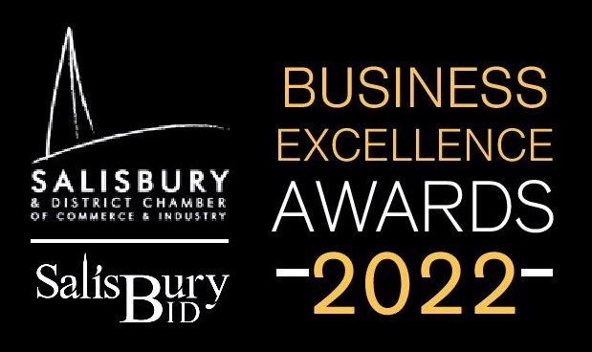
Application form
Innovation and Sustainability Award
The Innovation & Sustainability Award recognises any member providing new technology, product, or service that has been shown to demonstrably reduce costs, increase productivity, improve product quality or in some other way provide a bottom-line benefit that is innovative and sustainable.
Please complete the following information questions
Business name:
Year established:
Business address:
Business owner:
Business status ie: Limited Company/Partnership/Sole Trader
Number of employed staff:
Number of self-employed staff:
Name of applicant & email:
Relationship to business:
Business turnover:

Please complete the following award questions.
Q1. Type of business - what does it do?
Q2. What is the current market position of this business?
Q3. What impact has the product had on the profit/loss of this business over the past 3 years?
Q4. What impact has this creative solution had on the business overheads?
Q5. Describe the business plan for the next 5 years?
Q6. What is the recruitment, skill and training requirements for this business and product?
Q7. What impact has this product had on staffing requirements?
Q8. What makes this business product unique / innovative and original?
Q9. What inspired the creation of this product?
Q10. What makes this product sustainable?
Q11. What impact has this creative solution had on the environment?
Q12. Summarise how this product delivers "more for less"?
Q13. Apart from finance, how else is the success of the product measured?
Q14. Does the business have a green travel plan?
Q15. Is business support or a company mentor used?
Q16. How does the business attract its customers?
Q17. During Covid -19 lockdowns, what innovative way did the business manage its employees?
Q18. What does the business do with positive feedback?
Q19. How does the business encourage innovation & sustainability through its employees?
Q20. How does the business support other sustainable businesses or charities in the community?

Please return this questionnaire, along with any additional supporting information to info@salisburychamber.co.uk before midnight on Friday 11th March.
Please mark the subject line with the category of the award you are applying to win and the business name.
Judges will be in touch week commencing 14th March 2022 if you are required for an interview to gather more information.
Five businesses will be shortlisted for each award. There will be two places reserved for each shortlisted business representative and limited additional tickets available for general sale to members. Tickets are subsidised at £35.00 plus VAT per person.
To order tickets regardless of the award completion, please email as above with the subject line Tickets for BEA 2022.
We look forward to celebrating your business on Friday 8th April.

